Project Design Phase-II
Data Flow Diagram & User Stories

Date | 31 January 2026
Team ID | LTVIP2026TMIDS88360
Project Name | Civil Engineering Insight Studio
Maximum Marks | 4 Marks

Data Flow Diagrams:
A Data Flow Diagram (DFD) is a traditional visual representation of the information flows within a system. A neat and clear DFD can depict the right amount of the system requirement graphically. It shows how data enters and leaves the system, what changes the information, and where data is stored.
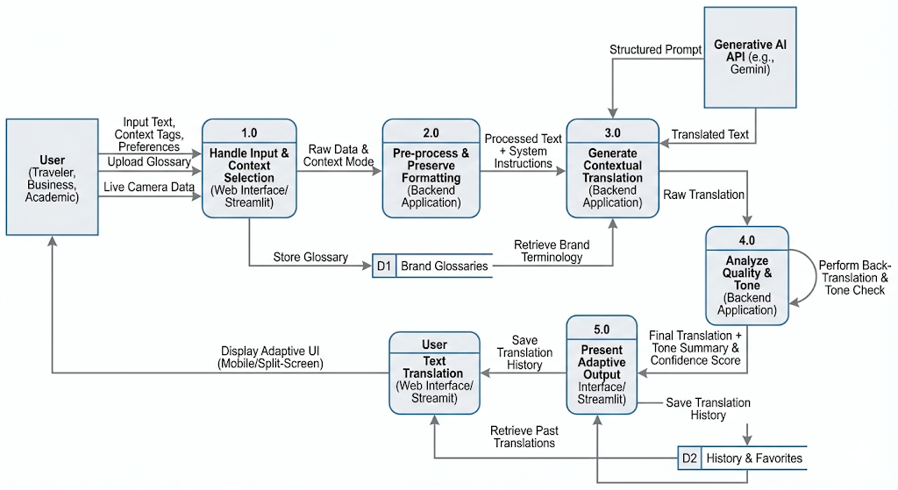

User Stories
Use the below template to list all the user stories for the product.
Release/Sprint | User Type | Epic | ID | User Story / Task | Acceptance Criteria | Priority
Sprint-1 | Customer (Web) | Core Translation Engine | USN-6 | As a user, I want to input text and select languages for instant AI translation. | Accurate Google Generative AI translation; side-by-side interface display. | High
Sprint-1 | Customer (Web) | Contextual Accuracy | USN-7 | As a Business Professional, I want a "Professional Tone" toggle for marketing docs. | Output avoids "robotic" phrasing; adheres to professional business standards. | High
Sprint-1 | Customer (Mobile) | Travel Accessibility | USN-9 | As a Traveler, I want a "Quick-Key" mobile interface for signs and menus. | High-contrast UI with large buttons; high performance on low bandwidth. | High
Sprint-1 | Administrator | System Monitoring | USN-10 | As an admin, I want to track API usage and latency for system stability. | Dashboard shows real-time AI usage stats and error logs. | Medium
Sprint-2 | Customer (Web) | Academic Integrity | USN-8 | As a Researcher, I want to upload docs while preserving jargon and citations. | System identifies and ignores LaTeX/citations; maintains scientific accuracy. | Medium

